OpenHIM Platform Deployment - Sri Lanka

|  |
| --- |
| **Deployment Artifact** |

**[Programme]**

**05 March 2024**

**[Version]**

## Document Control

|  |  |  |  |
| --- | --- | --- | --- |
| **Version** | **Description of Revision** | **Author** | **Date** |
| 0.1.0 | Draft Document | Ajeenckya Gadewar | 05-March-2024 |
|  |  |  |  |
|  |  |  |  |
|  |  |  |  |
|  |  |  |  |

# Table of Contents

Document Control 1

**Table of Contents 2**

**Introduction 3**

**Document Purpose 3**

**Target Audience 4**

**Installation Steps 5**

Step 1: System Update and Prerequisites 5

Installing Docker 5

Installing Docker Swarm 6

Step 2: Clone the repository at any user location (ex: ubuntu) 6

Step 3: Run the following commands to run complete stack on one server including OpenHIM, JeMPI, Mediators and HAPI FHIR 6

Snapshot of the dockers running 7

Step 4: Setup NGINX as reverse proxy server 7

Step 5: Install Letsencrypt Certbot 8

Step 6: Check if you can access OpenHIM 9

# 

# 

# Introduction

In the rapidly evolving landscape of healthcare information technology, the need for seamless integration between diverse health information systems has never been more critical. As healthcare providers and institutions strive to improve patient care while navigating complex regulatory environments, the ability to securely and efficiently exchange health information stands out as a cornerstone of modern healthcare IT. Enter the Open Health Information Mediator (OpenHIM) – a robust, flexible platform designed to facilitate this exact requirement.

The OpenHIM serves as a central mediator, enabling the secure and reliable exchange of health information between disparate systems. Whether it's between hospitals, clinics, laboratories, or public health databases, the OpenHIM streamlines communication, ensuring that critical health data is available where and when it's needed, in a format that's usable and compliant with relevant standards. This not only enhances the efficiency of healthcare delivery but also significantly contributes to improved patient outcomes by ensuring that care providers have timely access to the information they need.

Beyond its core functionality, the OpenHIM is designed with the complexities of healthcare IT environments in mind. It supports a range of interoperability standards and protocols, making it a versatile choice for integrating a wide array of health information systems. Furthermore, its architecture is built to scale, accommodating the growing data needs of healthcare institutions while maintaining high performance and reliability.

The platform consists of two main components: the OpenHIM-Core, which handles the routing, transformation, and logging of transactions, and the OpenHIM-Console, a user-friendly interface for configuring and managing the core's operations. Together, these components offer a powerful toolkit for overcoming the challenges of health information exchange, providing a foundation for building more connected, efficient, and patient-centred healthcare systems.

This guide is designed to walk you through the complete process of installing the OpenHIM stack on Ubuntu, from setting up the necessary prerequisites to configuring the system for use. Whether you're looking to deploy OpenHIM in a small clinic or a large healthcare network, this guide aims to provide the knowledge you need to succeed.

# Document Purpose

The primary purpose of this document is to serve as a comprehensive guide for the installation of the Open Health Information Mediator (OpenHIM) complete stack on an Ubuntu operating system. OpenHIM plays a pivotal role in facilitating secure and efficient health information exchange across various healthcare information systems. Despite its critical importance, the setup and configuration of OpenHIM can present a complex challenge, encompassing a range of technical steps from system prerequisites to final deployment and security measures.

This guide aims to demystify the installation process, offering clear, step-by-step instructions that ensure a successful setup of both the OpenHIM-Core and the OpenHIM-Console, as well as the integration of mediators for extended functionality. By providing detailed explanations, command-line snippets for installation, and configuration tips, this document intends to equip users with the necessary tools and knowledge to deploy OpenHIM effectively.

Moreover, this guide emphasises best practices for securing the installation, ensuring that the OpenHIM deployment aligns with the stringent security requirements inherent in handling sensitive health information. By the end of this document, readers should feel confident in their ability to install, configure, and secure an OpenHIM instance, facilitating seamless health information exchange within their organisation or network.

# Target Audience

This installation guide is tailored for a wide range of IT professionals engaged in the healthcare sector, including but not limited to:

* System Administrators: Those responsible for the maintenance, configuration, and reliable operation of computer systems, especially those running on Ubuntu. This guide provides system administrators with a clear roadmap for deploying OpenHIM within their IT infrastructure.
* Healthcare IT Specialists: Professionals specialising in the implementation and management of healthcare information technologies. This guide will help these specialists harness OpenHIM to improve data interoperability between disparate healthcare systems.
* Software Developers and Engineers: Those involved in developing or integrating healthcare applications will find this guide useful for understanding how to connect their applications with OpenHIM for data exchange purposes.
* Technical Project Managers: Managers overseeing IT projects in the healthcare domain can use this guide to understand the technical requirements and steps involved in setting up OpenHIM, facilitating better project planning and execution.
* Data Protection Officers and Compliance Personnel: Individuals responsible for ensuring that healthcare data handling practices comply with regulatory standards will benefit from the security practices outlined in this guide.

This document assumes that the target audience has a basic understanding of Linux/Ubuntu command-line interfaces, networking concepts, and general IT security principles. Prior experience with health information exchange concepts and technologies, while beneficial, is not required to follow the installation and configuration steps outlined in this guide.

# 

# Installation Steps

Deploying the Open Health Information Mediator (OpenHIM) complete stack on Ubuntu using Docker and Docker Swarm streamlines the process by encapsulating the application and its dependencies into containers. This method ensures consistency across different environments, simplifies configuration, and enhances scalability and manageability. The following steps outline the installation process from setting up Docker and Docker Swarm to configuring and securing your OpenHIM deployment.

### Step 1: System Update and Prerequisites

Before you can deploy OpenHIM using Docker, certain prerequisites must be met, which primarily involve setting up Docker and initialising a Docker Swarm cluster on your Ubuntu system. This foundation is crucial for the subsequent deployment and management of OpenHIM containers. Assuming, git is already installed.

#### Installing Docker

1. Update Your System: Ensure your Ubuntu system is up-to-date:

sudo apt update && sudo apt upgrade -y



1. Install Docker: Install Docker using the convenience script provided by Docker, which automates the installation of Docker on Linux:

curl -fsSL https://get.docker.com -o get-docker.sh

sudo sh get-docker.sh



1. Manage Docker as a Non-root User: Add your user to the docker group to manage Docker as a non-root user:

sudo usermod -aG docker ${USER}

1. Apply Changes: Log out and back in for the group changes to take effect, or you can apply the new group membership immediately with:

newgrp docker

#### Installing Docker Swarm

1. Initialise Swarm Mode: On your Docker host, initialise a new Swarm:

docker swarm init



1. Note the Swarm Join Token: After initialising, note down the join token command for adding worker nodes to your Swarm. This step is crucial for scaling your OpenHIM deployment across multiple machines if necessary.

### Step 2: Clone the repository at any user location (ex: ubuntu)

git clone [jembi/srilanka-on-platform (github.com)](https://github.com/jembi/srilanka-on-platform)



### Step 3: Run the following commands to run complete stack on one server including OpenHIM, JeMPI, Mediators and HAPI FHIR

cd srilanka-on-platform

./deploy-ips.sh # Wait for this command to complete. It will build complete stack cd mapping_mediator/  
docker build -t ocl-mapping-mediator .  
cd ..  
./instant-linux package up --name mapping-mediator --only



### Snapshot of the dockers running

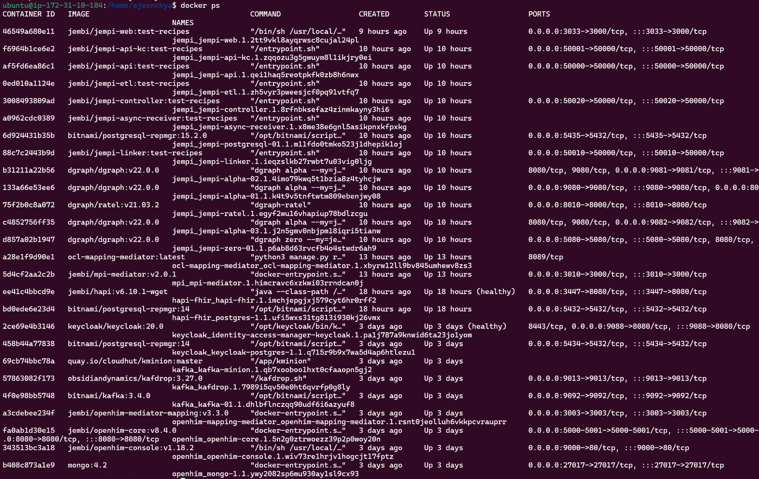

### Step 4: Setup NGINX as reverse proxy server

1. Install NGINX

sudo apt install nginx



1. Create a new configuration file

sudo nano /etc/nginx/sites-available/openhim-core.conf



1. Edit above configuration file

server{

listen 80;

listen [::]:80;

server_name nehr.health.gov.lk;

# security

include nginxconfig.io/security.conf;

# logging

access_log /var/log/nginx/access.log combined buffer=512k flush=1m;

error_log /var/log/nginx/error.log warn;

# reverse proxy

location / {

proxy_pass http://127.0.0.1:9000;

proxy_set_header Host $host;

include nginxconfig.io/proxy.conf;

}

location ^~ /openhim-core {

rewrite ^/openhim-core/(.*) /$1 break;

proxy_pass https://127.0.0.1:8080;

proxy_set_header Host $host;

include nginxconfig.io/proxy.conf;

}

location ^~ /openhim-core-http {

rewrite ^/openhim-core-http/(.*) /$1 break;

proxy_pass http://127.0.0.1:5001;

proxy_set_header Host $host;

include nginxconfig.io/proxy.conf;

}

include nginxconfig.io/general.conf;

}



1. Enable the configuration

sudo ln -s /etc/nginx/sites-available/openhim-core.conf /etc/nginx/sites-enabled/

sudo nginx -t # Should show Status OK

sudo systemctl restart nginx



### Step 5: Install Letsencrypt Certbot

1. Install Certbot and the NGINX Plugin

sudo apt update

sudo apt install certbot python3-certbot-nginx -y



1. Obtain a Let's Encrypt SSL Certificate

sudo certbot --nginx -d nehr.health.gov.lk



1. Restart NGINX

sudo nginx -t

sudo systemctl restart nginx



### Step 6: Check if you can access OpenHIM

<https://nehr.health.gov.lk>

Username: [root@openhim.org](mailto:root@openhim.org)

Password: instant101

